What is #OwnVoices
By Lydia Frankenburger

Not long before I attended the 2019 ALA Midwinter Conference I saw #ownvoices on a list for types to book to read for the year, which made me reflect about the books I get for my high school. Am I getting books that my students identify with? I like to think I am, but I need to make sure I am more conscious about it. I should add that a month or so before seeing the hashtag one of my big fantasy readers pointed out that he was not seeing any new fantasy books with a male protagonist. Because of this conversation, I searched for more recently published fantasy books with a male protagonist, which I found is not easy. I also connected the student with one of my favorite fantasy books, The Name of the Wind by Patrick Rothfuss, which he loved, but I digress.

When I saw that there was a session featuring #ownvoices authors I knew I needed to attend to hear what the authors had to say about writing #ownvoices books. There were four #ownvoices on the panel with a fifth as the moderator.

- Alex R. Kahler is gay whose main character in his fantasy novel is also gay.
- Allison Gervais is Hard of Hearing (HOH) and works with the Deaf and HOH. The main character in her book, The Silence Between Us, is a deaf teenage girl who moves to a new school her senior year.
- KimTurissi is a lesbian author who adapted Shaftesbury queer vampire web series, Carmilla, into a novel.
- Natasha Deen was born and lived in Guyana until her parents moved to Canada to escape violence. The main character in In the Key of Nira Ghan is a Guyanese girl.
- Moderator, Dana L. Davis, is an African-American woman and author of Tiffany Sly Lives Here Now whose main character is also African American.

It was interesting listening to how important it was for the authors to create characters that they can personally identify with and in turn many readers could identify with, too.

The surprise at the end of the session was all five authors signed an advance reader copy of their book for everyone at the session.

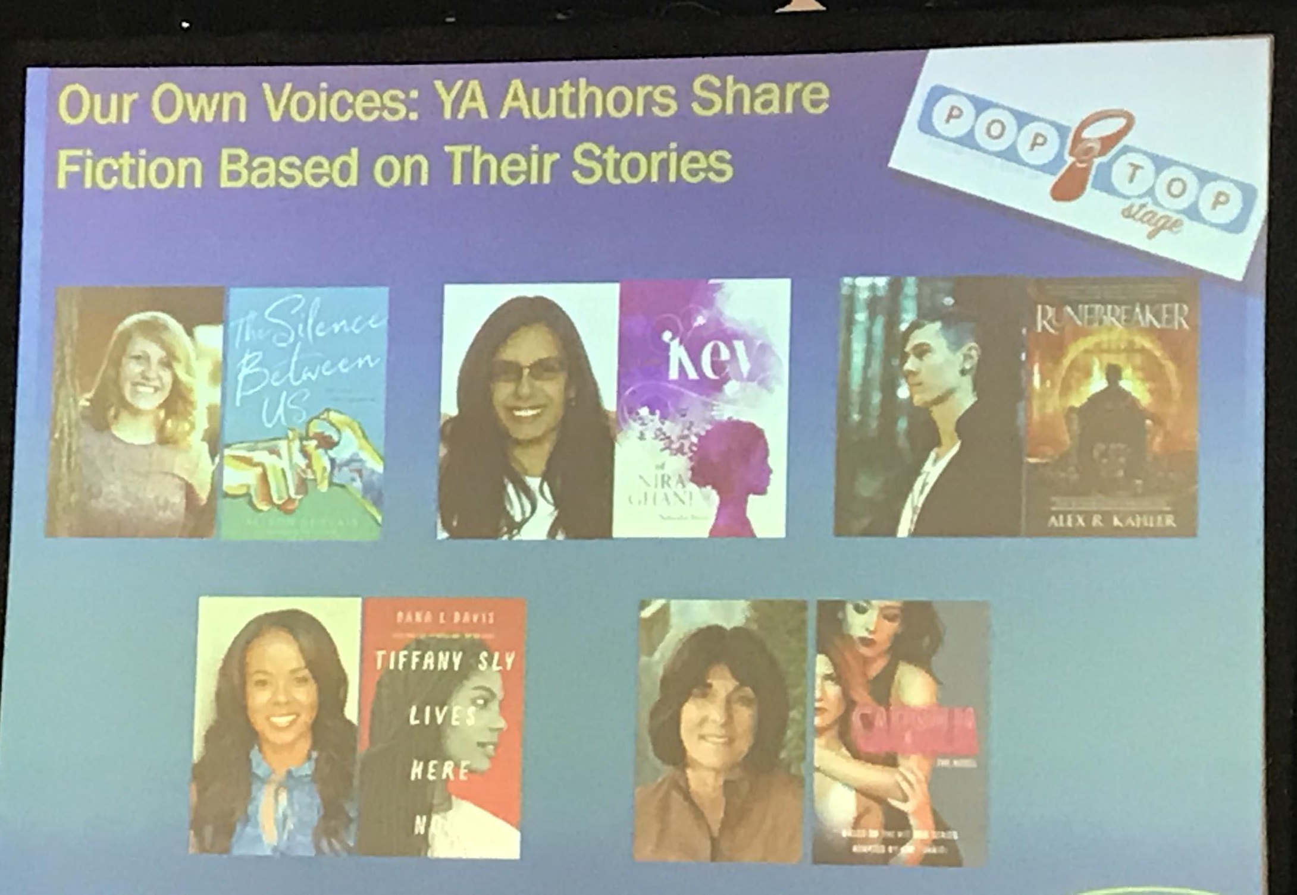
I am going to suggest to the reader who I mentioned above who was looking for more male protagonist in new fantasy books to think about writing a book of his own. Maybe someday we will see a Pakistani male protagonist in a fantasy series.

This image was on the screen during the session.
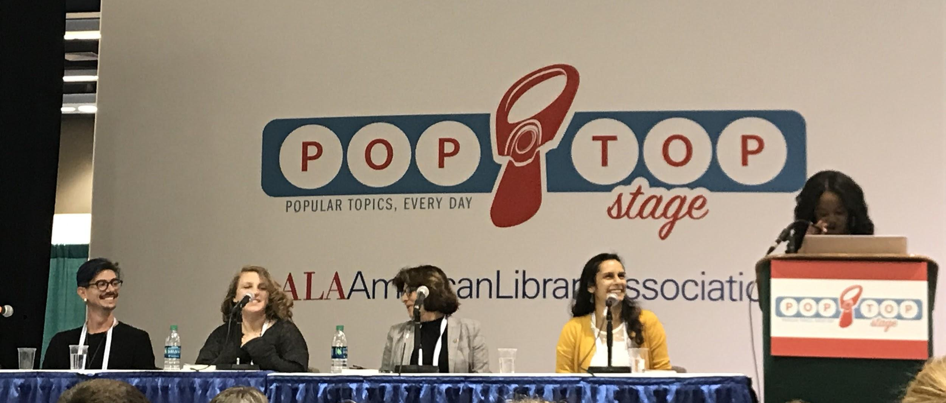

Alex R. Kahler, author of Runebreaker, Alison Gervais, author of The Silence Between Us, Kim Turrisi, author of Carmilla, Natasha Deen, author of In the Key of Nira Ghani, and moderator Dana L. Davis, author of Tiffany Sly Lives Here Now.

Note: The titles mentioned are the most current books by the authors and at the time had yet to be published.

