ASTE Session: Engaging Learners through Technology, presented by Carrie Day, Wasilla Middle School.
I love being inspired in a session, and that’s exactly what happened when I attended Carrie Day’s session on Engaging Learners through Technology.
Similar to Carrie, I use technology to connect with my students. I even created a ‘Digital Makerspace’ last summer after attending the School Librarian Leadership Academy and it later showed up in a Puffin article (http://www.akasl.org/puffin-news/digital-makerspace-what-will-you-make). I had used a Symbaloo to showcase the links. Presentation sites on the left, coding on the right, publishing at the top, audio & visual at the bottom.
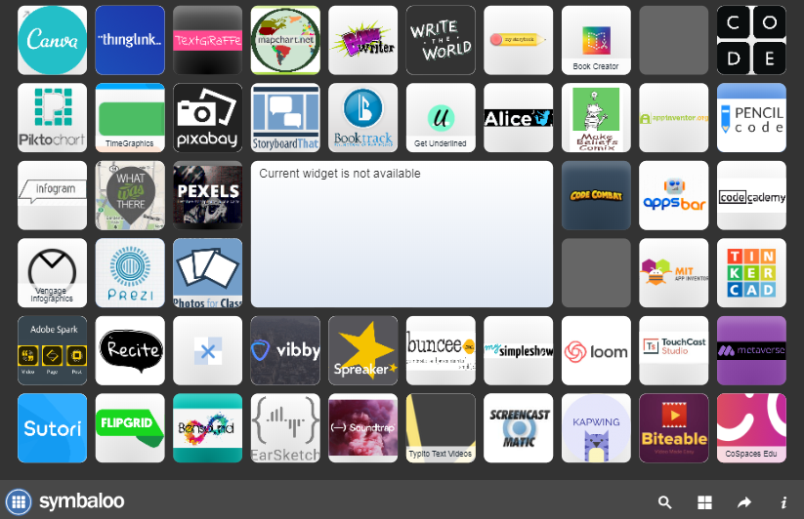
(screenshot of Valdez High School Library Digital Makerspace Symbaloo – retrieved March 17, 2019, https://www.valdezcityschools.org/Page/1762)
Carrie, however, does it better. Much better. I walked away with some helpful hints and ideas for some of the tech sites, and also inspiration to redo my own school website.
First, let’s talk about the website. Instead of just providing links to the sites, she broke them down into groups and created pages for each category.
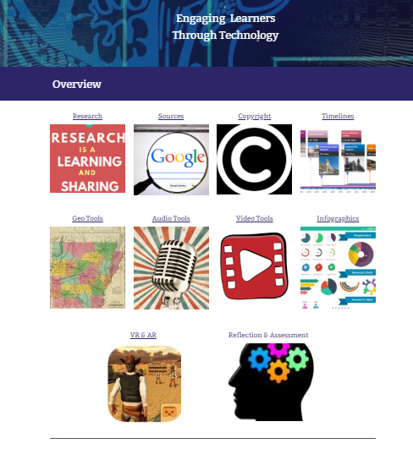
Screenshot of Carrie’s site, retrieved March 17, 2019, https://sites.google.com/apps.matsuk12.us/aste2019/home?authuser=0)
When you visit a category page, you will find annotations to help you decide which tool to use. When possible, she has embedded videos that give an overview of the tool. You might also find ideas to incorporate the tools into lessons or potential issues with a tool (such as a sharing problem for students in the MatSu School District).
I particularly liked her Timelines Page (https://sites.google.com/apps.matsuk12.us/aste2019/tech-tools/timlines?authuser=0, all screenshots below were retrieved on 3/17/2019) and think that it shows some great examples of helpful information for teachers and students.
You can see that first she gives an overview of timelines – what they are and why you’d want to use them.
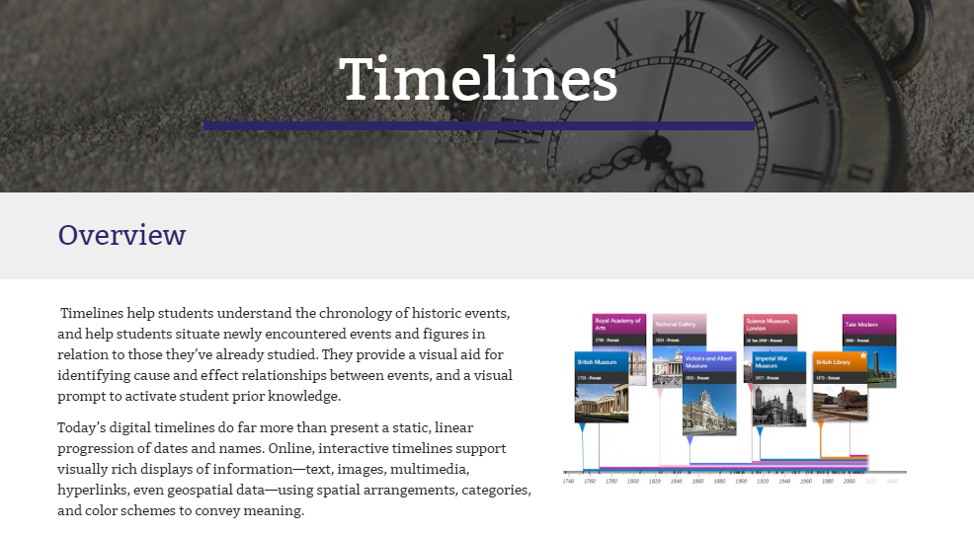
Next, she has a video with suggestions on how to incorporate “Timelines for Kids”.
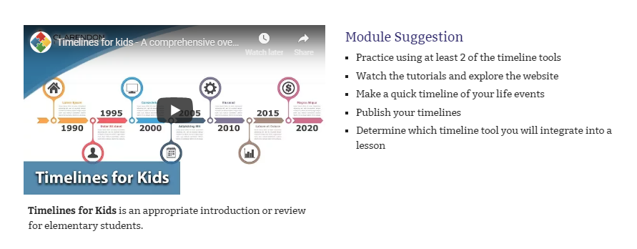
The next section on this page has six different timeline tools, with informational videos and a short written description of the tool.
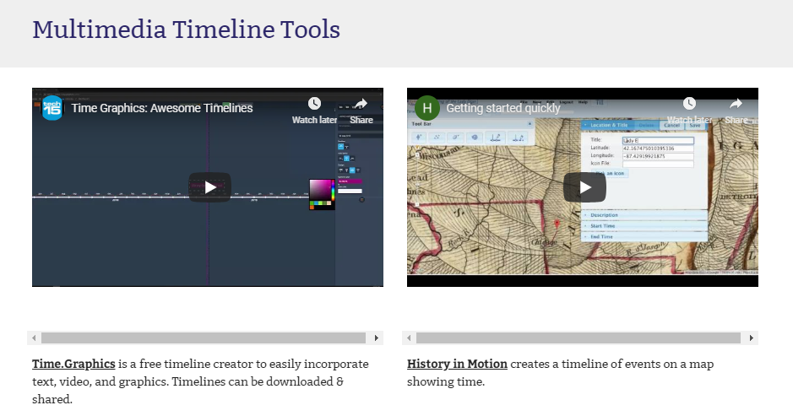
Finally, at the bottom she has links to other sites, and an explanation why one of them can only be used by teachers, not students.
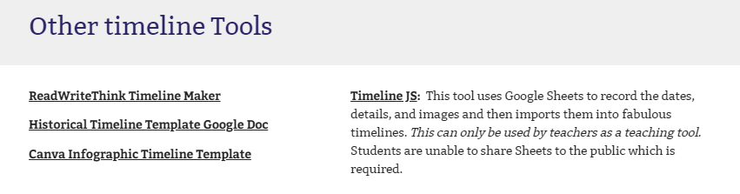
Now that you are inspired to go explore Carrie’s website, I’ll share a few quick tips that I also picked up during this session.
- Keep track of your informational videos that you have embedded on your website by making a playlist in YouTube.
- If your class enjoys Mystery Skype, but is unable to connect with a classroom in a different time zone due to scheduling conflicts, you can use Padlet.com to ask/answer questions.
- Vocaroo (or other audio tool) lets you give verbal feedback to your students so they can hear you talking about their paper. Students can use it for reflections or comments.
- Carrie recommends podcasts for students to listen as a prep for a lesson, rather than reading from a text book or watching a video. She suggests that they can listen while doing something else so they are likely to stay engaged longer.
- Carrie uses Animoto to make book trailers. She always puts credits for pictures, etc. at the end of the video.
- Carrie says that if you use Animoto Education (take pictures, add words, music, etc.), you can contact them and get a code for students to get a slightly longer video with no watermark. Carrie has never been denied when asking for seats for education. If you go to their site, (https://animoto.com/business/education), you can get information on creating school marketing videos. You can also get video marketing assistance.
- One final fun thing – check out the Curiscope science shirt. I think kids would LOVE this augmented reality experience exploring human anatomy!

